PARK-O-MATIC

Project report submitted in partial fulfilment of the requirements for the Final Year of Computer Science Engineering

by

Sohail Shaikh PRN No. - 211112008

Hrutuja Brahmankar PRN No. - 211112009

Shivani Agrawal PRN No. - 211112026

Mrunmai Basutkar PRN No. - 211112037

Under the guidance of

Prof. Mr. Amol H. Patil



Department of Computer Science Technology

A. C. Patil College of Engineering, Kharghar, Navi Mumbai University of Mumbai

2023-2024

# Institute Vision and Mission

VISION

To create skilled professionals and engineers for catering the needs of industries and society.

MISSI ON

To provide qualified faculty and required infrastructure to impart quality education inculcating continuous learning attitude

To provide platform for the interaction between academia and industry.

To inculcate social values and responsible attitude amongst students through co-curricular and extracurricular activities.

# Department Vision and Mission

VISION

To create knowledgeable CS professionals equipped with employable skills.

MISSION

1. To build foundation of emerging technologies with interactive teaching learning approach.
2. To Provide facilities for learning advanced technologies with industry interaction.
3. To impart social skills by encouraging co-curricular and extra-curricular activities.

## CERTIFICATE

This is to certify that the project entitled**” PARK-O-MATIC”** is a bonafide work of **Sohail Anwar Shaikh (211112008), Hrutuja Rahul Brahmankar (211112009), Shivani Sanjay Agrawal (211112026), Mrunmai Mahesh Basutkar (211112037)** of **A. C. Patil College of Engineering, Kharghar** have submitted to University of Mumbai in partial fulfilment of the requirement for award of Final year of Bachelor of Engineering in Computer Science Engineering from University of Mumbai.

Internal Examiner External Examiner

Dr. V. N. Pawar

Head Of Department Principal

## Project Report Approval for B. E.

This project report entitled **PARK-O-MATIC** by **Sohail Anwar Shaikh (211112008), Hrutuja Rahul Brahmankar (211112009), Shivani Sanjay Agrawal (211112026), Mrunmai Mahesh Basutkar (211112037)** is approved for the degree of” Bachelor **of Computer Science Engineering”**.

Examiners

1.

2.

Date:

## DECLARATION

I declare that this written submission represents my ideas and does not involve plagiarism. I have adequately cited and referenced the original sources wherever others’ ideas or words have been included. I also declare that I have adhered to all principles of academic honesty and integrity and have not misrepresented or fabricated or falsified any idea/data/fact/source in my submission. I understand that any violation of the above will be cause for disciplinary action against me by the Institute and can also evoke penal action from the sources which have thus not been properly cited or from whom proper permission has not been taken when needed.

Sohail Shaikh PRN No. - 211112008

Hrutuja Brahmankar PRN No. - 211112009

Shivani Agrawal PRN No. - 211112026

Mrunmai Basutkar PRN No. - 211112037

## Acknowledgement

It is with immense pleasure and satisfaction that we express our gratitude and thanks to the people who have contributed in making our project work and enriching experience.

I express our gratitude towards my guide Mr. Amol H. Patil for supporting throughout the year for successfully completing my project.

Date:

Sohail Shaikh PRN No. - 211112008

Hrutuja Brahmankar PRN No. - 211112009

Shivani Agrawal PRN No. - 211112026

Mrunmai Basutkar PRN No. - 211112037

# **ABSTRACT**

Park-O-Matic represent an innovative approach to addressing the persistent urban challenge of parking management. These systems leverage advanced technologies, such as sensors, data analytics, and mobile apps, to enhance the efficiency and convenience of parking for both drivers and facility operators. This abstract explores the key components and benefits of smart parking systems, highlighting their capacity to reduce traffic congestion, optimize resource allocation, improve user experience, and contribute to environmental sustainability. Furthermore, it underscores the potential for data-driven decision-making in urban planning and transportation management, making smart parking systems a cornerstone of future urban mobility solutions. With a vision of creating more accessible and eco-friendly urban environments, smart parking systems are poised to revolutionize the way we approach parking in cities worldwide.

**Contents**

Institute Vision and Mission 2

Department Vision and Mission 3

CERTIFICATE 4

Project Report Approval for B. E. 5

DECLARATION 6

Acknowledgement 7

ABSTRACT 7

List of Tables 10

Chapter 1 2

Introduction 2

1.1 Existing System 3

1.2 Proposed System 4

1.3 Scope 4

Chapter 2 5

2.1 Literature Survey 5

Chapter 3 6

3.1 Proposed System 6

3.2 Block Diagram 7

3.3 DFD Diagram 8

3.4 Hardware Requirement 9

3.4.2 Servo Motor 10

3.4.3 IR Proximity Sensor 10

3.4.4 Ultrasonic sensor 11

3.4.5 RFID Tag 11

3.4.6 Buzzer 12

3.4.7 LCD 12

3.4.8 LED 13

3.4.9 Potentiometer 13

3.5 Software Requirement 14

3.5.1 Arduino IDE 14

3.6 Working 14

3.7 Working Code 17

Chapter 4 21

4.1 Results and Discussion 21

4.2 Previous work 22

Chapter 5 24

5.1 Advantage 24

5.2 Disadvantage 25

6.2 Future Scope 27

References 29

# **List of Tables**

* 1. Literature Survey 3

**List of Figures**

Figure 1. Block Diagram I 8

Figure 2. Block Diagram II 9

Figure 3. DFD Diagram 9

Figure 4. Arduino UNO 10

Figure 5. Servo Motor 11

Figure 6. IR Proximity Sensor 11

Figure 7. Ultrasonic Sensor 12

Figure 8. RFID Tag 12

Figure 9. Buzzer 13

Figure 10. LCD 13

Figure 11. LED 14

Figure 12. Potentiometer 14

Figure 13 Entry Gate with Arduino UNO (I) 23

Figure 14 RFID TAG and LCD Working 24

Figure 15 Parking Slots 25

Figure 16 Connection of Parking Slots 26

Figure 17 Exit Gate Arduino UNO (II) 27

Figure 18 Exit Gate Working 28

Figure 19 Project Model 29

# **Chapter 1**

## Introduction

The advent of urbanization and the ever-increasing number of vehicles on the road have given rise to numerous challenges, and one of the most pervasive among them is the issue of parking. Finding a convenient and available parking spot in densely populated urban areas has become a daily struggle for drivers, leading to traffic congestion, environmental concerns, and frustration.

Park-O-Matic Systems have emerged as a transformative solution to this age-old problem. These systems leverage cutting-edge technologies and data-driven strategies to optimize the management of parking spaces, making the entire process more efficient, user-friendly, and environmentally sustainable. By integrating a variety of sensors, data analytics, mobile apps, and communication networks, smart parking systems provide real-time information on parking space availability, streamline the parking process, and significantly enhance the overall urban mobility experience.

This project focuses on analyzing parking patterns, optimizing parking space utilization, and enhancing the overall parking experience for both motorists and city authorities. By integrating data collection technologies, such as sensors and cameras, with advanced analytics and machine learning algorithms, we aim to provide real-time parking availability information, predictive parking guidance, and intelligent parking enforcement strategies.

In this era of urbanization and the continuous growth of vehicle populations, the smart parking system represents not only a response to the parking challenges of today but also a vision for the cities of the future. This introduction delves into the key components, benefits, and transformative potential of smart parking systems, shedding light on how they can revolutionize urban mobility and offer a path toward more accessible, eco-friendly, and efficient city living.

## Existing System

Parking systems in India encompass a diverse range of solutions due to the country's varying urban landscapes and transportation needs. On-street parking is a common sight in Indian cities, with vehicles parked alongside roads, often managed by municipal authorities or local attendants. Off-street parking lots, both open-air and multi-level, are prevalent in urban areas, typically requiring users to pay for the time their vehicle is parked.

Some Indian cities have introduced smart parking systems that employ technology to monitor parking space availability in real-time, providing users with convenient information on available parking spots through mobile apps or digital signage. Valet parking services are frequently found in commercial areas, offering a convenient parking experience. Additionally, parking meters and automated parking systems are present in select areas.

Residential permit parking and bicycle parking facilities are implemented to cater to specific needs, while electric vehicle charging stations are emerging to support the growing EV market. Smart Parking is an innovative parking system implemented in downtown areas to address the challenges of urban parking. Developed in collaboration with city authorities and technology partners, Smart Parking integrates cutting-edge technologies to streamline parking operations, improve accessibility, and enhance the overall urban experience. The parking landscape in India continues to evolve as urbanization and transportation demands change, with some cities exploring innovative solutions to alleviate parking-related challenges and traffic congestion.

ParkSmart is a comprehensive parking management system implemented in the downtown area of CityX. Developed in partnership with CityX's municipal authorities and a leading technology firm, ParkSmart aims to alleviate parking congestion, enhance user experience, and optimize parking space utilization.

## Proposed System

A proposed Park-O-Matic system using Arduino is designed to alleviate the perennial problem of finding parking spaces in crowded urban areas. This system employs a network of sensors, including IR sensors positioned at individual parking spots and an ultrasonic sensor at the entrance to the parking facility. The IR sensors detect vehicle presence, relaying this information to the central Arduino controller, which processes the data in real-time to determine the availability of each parking space. A LED display or LCD screen at the entrance of the parking lot informs drivers of the number of open parking spaces. Optionally, physical barriers, such as gates, can be controlled by servo motors to restrict entry into full lots. Moreover, wireless communication through Wi-Fi or Bluetooth enables drivers to access this real-time parking information via a mobile app or website, empowering them to quickly locate available spaces and reserve them if desired. Overall, this proposed system enhances the efficiency of parking facilities, reduces traffic congestion, and improves the user experience by making parking more accessible and convenient for urban commuters.

## Scope

The scope of Park-O-Matic is broad and dynamic, offering solutions to the pressing challenges of urbanization and transportation in the 21st century. These systems are designed to address a wide array of issues, including traffic congestion, resource optimization, and environmental sustainability. Smart parking systems aim to significantly enhance urban mobility by efficiently guiding drivers to available parking spaces, reducing time and fuel wasted in the search for parking, and ultimately making cities more navigable. They also contribute to the environmental agenda by promoting eco-friendly practices such as electric vehicle charging infrastructure and bicycle parking. Beyond these immediate benefits, smart parking systems generate valuable data that can inform data-driven urban planning, resulting in more efficient traffic management, reduced illegal parking, and improved safety. With their vast potential for economic opportunities, inclusivity, and integration with public transport, the scope of smart parking systems extends well beyond the mere act of parking, making them a pivotal element in shaping the cities of the future**.**

# **Chapter 2**

## 2.1 Literature Survey

|  |  |  |  |
| --- | --- | --- | --- |
| **Project Name** | **Project Authors** | **Advantages** | **Disadvantages** |
| IoT based Car Parking Management System using IR Sensor | Khairul Anwar Sedek, Karthik Reddy Jupalli | It integrates a node MCU as microcontroller with IR sensor and LCD screen | The proposed parking system is developed using the Internet of Things (IoT) technology with the maximum cost, and with heavy servers. |
| Smart parking assistance using Arduino | S.K. Satyanarayana, A. Akhil, G. Padmini | Car Parking Management System with IR Sensor was created as a prototype to help drivers locate a vacant or available parking spot | The suggested parking system's prototype was designed for a single storage parking space, but not expanded to accommodate several storage spaces. |
| Smart parking system | Raj Mani, Vagish V Bhat | Try to display the start time and end time so that the user can know for what amount of time he has parked his vehicle | This situation leads to the unnecessary crowding of vehicles on the road and results in inconvenient. |
| Smart CAR parking System using Arduino | Sobith Jain, Siddhartha Singh Tomar | It is cost efficient | It cannot be upgraded much in future. |

**Table 2.1: Literature Survey**

# **Chapter 3**

## 3.1 Proposed System

In increasingly crowded urban landscapes, the search for parking spaces has become a ubiquitous challenge, contributing to traffic congestion, fuel wastage, and driver frustration. To address this issue, a Park-O-Matic System emerges as a beacon of efficiency and convenience. This system utilizes an arsenal of advanced technologies, including Arduino microcontrollers, IR sensors, ultrasonic sensors, servo motors, Buzzers and LCD displays, to transform the parking experience. By integrating these components, it not only optimizes the utilization of parking spaces but also enhances user accessibility and experience.

Park-O-Matic leverages a combination of proximity sensors, RFID tags, servo motors, ultrasonic sensors, and a buzzer to create an intelligent and efficient parking management solution. Park-O-Matic aims to revolutionize the traditional parking experience by providing real-time parking availability information, seamless entry and exit processes, and enhanced user convenience.

Upon arriving at the parking facility, drivers will be guided to available parking spaces. As the vehicle approaches the entry gate, the RFID tag is automatically detected, granting access and recording entry time. Inside the parking area, ultrasonic sensors assist the driver in parking accurately. When exiting, the RFID tag is once again authenticated, and the servo motor opens the gate for seamless departure. In case of any obstacles or safety concerns, the buzzer provides immediate feedback to the driver.

## 3.2 Block Diagram

Here is a simplified block diagram of out project with all the components mentioned as below:-

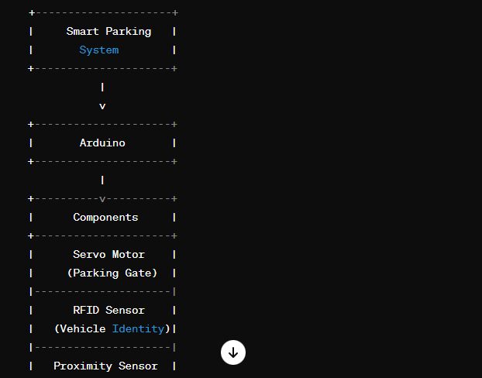

Figure 1. Block Diagram I

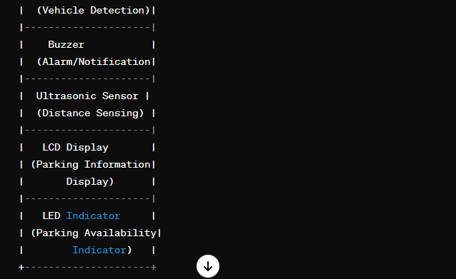

Figure 2. Block Diagram II

## 3.3 DFD Diagram

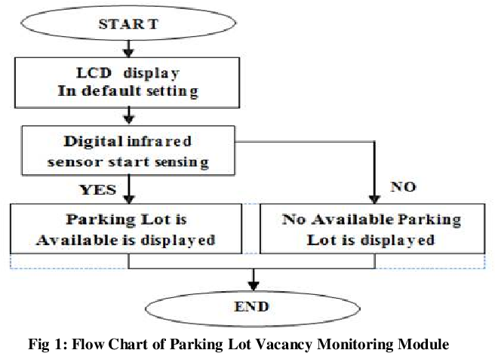

Figure 3. DFD Diagram

**Explanation: -**

The "Park-O-Matic" represents the core system, encompassing essential components like IR sensors, the LCD display, and a control unit (e.g., Arduino) that processes data from the sensors. In this context, the "Driver" actor uses the "Check Parking Slot Availability" and "View Parking Lot Information" use cases to interact with the system.

The use case diagram serves as a high-level visualization of how drivers engage with the LCD display within the broader smart parking system framework. It illustrates how the display, driven by data from IR sensors, empowers users to make informed decisions regarding parking slot availability, thus contributing to a more efficient and user-friendly parking experience.

## 3.4 Hardware Requirement

3.4.1 Arduino UNO

The Arduino Uno is a popular microcontroller board based on the ATmega328P chip. It is widely used by hobbyists, students, and professionals alike for creating a variety of electronic projects, from simple LED blinkers to more complex robotics and automation systems. It is widely used in various electronics projects and prototyping due to its simplicity, versatility, and ease of use.

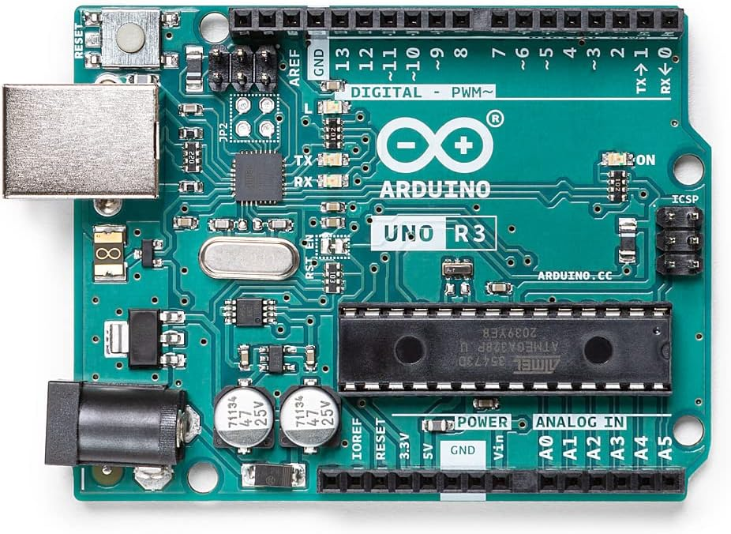

Figure 4. Arduino UNO

### 3.4.2 Servo Motor

A servo motor is a type of motor commonly used in robotics, RC (remote-controlled) vehicles, automation, and other applications where precise control of angular position is required. Unlike a regular DC motor, which rotates continuously when power is applied, a servo motor can rotate to a specific angle and hold that position.

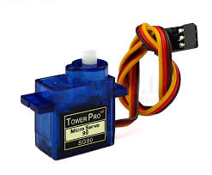

Figure 5. Servo Motor

### 3.4.3 IR Proximity Sensor

An IR proximity sensor is a type of sensor that detects the presence of an object or obstacle by emitting infrared light and measuring the reflection of that light. These sensors are commonly used in robotics, automation, and security systems for detecting nearby objects without physical contact.

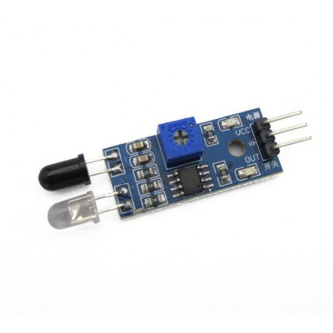

Figure 6. IR Proximity Sensor

### 3.4.4 Ultrasonic sensor

An ultrasonic sensor is a device that measures the distance to an object by emitting high-frequency sound waves and then detecting the time it takes for the sound waves to bounce back after hitting the object. These sensors are commonly used in robotics, automation, and various industrial applications for proximity sensing, object detection, and distance measurement.

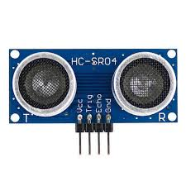

Figure 7. Ultrasonic Sensor

### 3.4.5 RFID Tag

An RFID (Radio-Frequency Identification) tag is a small electronic device that contains a unique identifier and communicates with an RFID reader wirelessly using radio waves. These tags are commonly used for tracking and identification purposes in various industries, including retail, logistics, transportation, and access control systems.

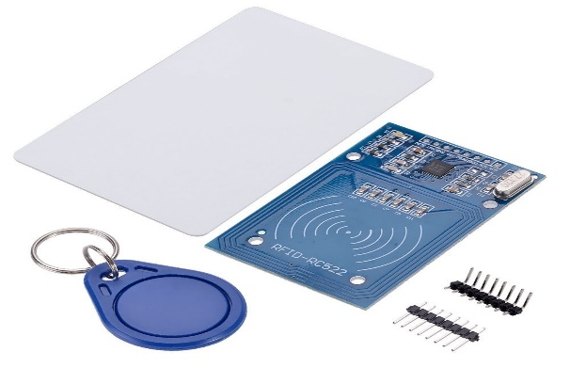

Figure 8. RFID Tag

### 3.4.6 Buzzer

A buzzer is an electronic component that produces sound when an electrical signal is applied to it. It is commonly used in various applications for generating audible alerts, notifications, or alarms.

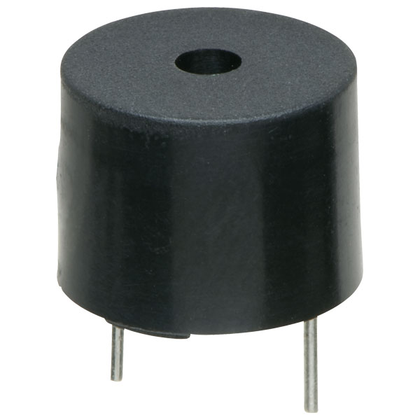

Figure 9. Buzzer

### 3.4.7 LCD

An LCD (Liquid Crystal Display) is a flat-panel display technology that uses liquid crystals sandwiched between two layers of polarizing material to create images. LCDs are widely used in consumer electronics such as televisions, computer monitors, smartphones, and digital watches.

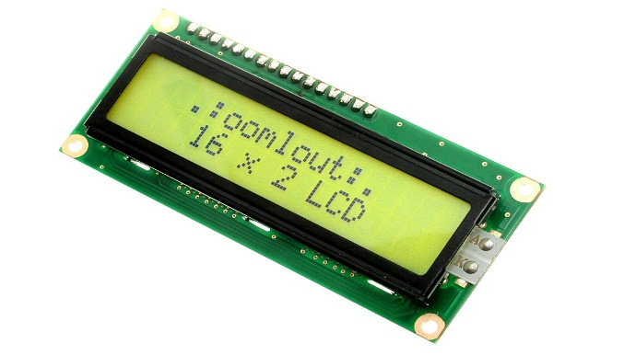

Figure 10. LCD

### 3.4.8 LED

LED stands for Light-Emitting Diode. It's a semiconductor device that emits light when an electric current passes through it. LEDs are widely used in various applications due to their efficiency, durability, and versatility.

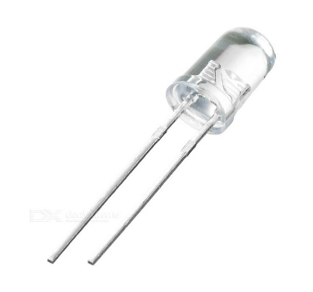

Figure 11. LED

### 3.4.9 Potentiometer

A potentiometer, often referred to as a "pot," is a three-terminal resistor with a sliding or rotating contact that forms an adjustable voltage divider. It is a common electronic component used to control electrical resistance in a circuit manually.

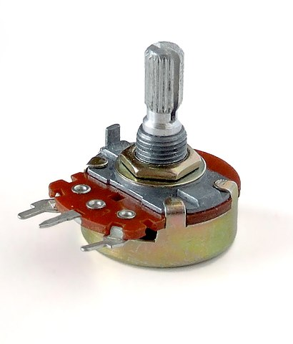

Figure 12. Potentiometer

## 3.5 Software Requirement

### 3.5.1 Arduino IDE

The Arduino IDE (Integrated Development Environment) is used to write the computer code and upload this code to the physical board. The Arduino IDE is very simple and this simplicity is probably one of the main reason Arduino became so popular. We can certainly state that being compatible with the Arduino IDE is now one of the main requirements for a new microcontroller board. Over the years, many useful features have been added to the Arduino IDE and you can now manage third-party libraries and boards from the IDE, and keep the simplicity of programming the board.

## 3.6 Working

The entry process of a vehicle into the parking facility involves a seamless integration of RFID sensing technology and servo motor control, ensuring efficient and secure access management. Upon the approach of a vehicle towards the entrance, the RFID sensor detects the presence of the RFID tag affixed to the vehicle. This tag serves as a unique identifier linked to authorized access privileges within the system. Upon successful RFID tag detection, access to the parking facility is granted. This decision triggers the servo motor mechanism responsible for opening the gate, allowing the vehicle to enter the premises. To provide real-time feedback to the user and confirm successful access, pertinent information, such as "Access Granted," is displayed on an LCD (Liquid Crystal Display) screen positioned at the entry point. This integrated system not only facilitates swift and automated entry processes but also enhances security and user experience within the parking facility.

After the vehicle successfully enters the parking facility, the system monitors the availability of parking slots to ensure efficient utilization of space. As the vehicle proceeds to its designated parking spot, sensors installed in each parking slot detect the presence of the vehicle and relay this information to the central control system. The control system updates the status of the parking slot accordingly.

In the event that all parking slots are occupied and no vacant spots are available, a message indicating "Parking Slot Full" is displayed on the LCD screen. This notification serves as real-time feedback to incoming vehicles, informing them of the unavailability of parking space within the facility. Additionally, the system may activate visual indicators, such as LED lights, near the entrance to signal the status of parking availability to approaching vehicles.

By providing timely information on parking availability, the integrated system enhances user experience, minimizes congestion, and optimizes the utilization of parking space within the facility.

Ultrasonic sensor is deployed to detect the proximity of the vehicle to obstacles such as walls within the parking space. As the vehicle approaches too close to the wall, the ultrasonic sensor detects the distance between the vehicle and the obstacle in real-time.

When the distance falls below a predetermined threshold, indicating that the vehicle is in danger of colliding with the wall, the system triggers an alert mechanism. This alert mechanism may include activating a buzzer to emit audible warnings to the driver, signaling the need to stop or brake the vehicle to avoid collision.

The buzzer emits a distinct sound pattern that grabs the driver's attention, prompting them to take corrective action and ensure safe parking. This proactive safety feature enhances the overall user experience, reduces the risk of accidents, and protects both the vehicle and the surrounding infrastructure.

After the vehicle exits the parking slot and leaves the premises, the system triggers an update on the LCD display to reflect the newly vacant parking slot. The LCD screen dynamically updates to show the availability status of each parking slot in real-time.

Simultaneously, the system may emit a brief confirmation message on the LCD screen, indicating the successful exit of the vehicle and the corresponding parking slot's status change to "Empty." This visual feedback confirms to other drivers and the parking facility management that the slot is now available for use.

By providing timely updates on parking slot availability, the system streamlines parking operations, enhances user convenience, and optimizes space utilization within the parking facility.

In Park-o-matic setup, we utilize various sensors and actuators to efficiently manage parking slots and ensure smooth vehicle flow. Here's a breakdown of the components and their functionalities: IR Sensors for Parking Slots: We employ three infrared (IR) sensors, each dedicated to monitoring a parking slot. These sensors detect the presence of vehicles within their respective slots. They are connected to pins irSensorPin1, irSensorPin2, and irSensorPin3. The status of each slot, whether occupied or empty, is determined by these sensors. This information is crucial for guiding incoming vehicles to available parking spaces. IR Sensor for Exit Gate: A single IR sensor is positioned at the exit gate to detect vehicles approaching for exit. Connected to exitIRPin, this sensor triggers the operation of the exit gate servo motor based on vehicle presence. The exit gate opens automatically upon detection of a vehicle, facilitating smooth egress from the parking area. Servo Motor for Exit Gate: To control the opening and closing of the exit gate, we employ a servo motor connected to exitServoPin. Upon activation by the exit IR sensor, the servo motor swings the gate open, allowing vehicles to exit. Once the vehicle has passed, the gate closes automatically, ensuring security and traffic management. Ultrasonic Sensors with Buzzers: For obstacle detection and collision prevention, three ultrasonic sensors are strategically placed around the vehicle. Each sensor—front, rear, and side—is paired with a buzzer to provide audible alerts in case of proximity to obstacles. These sensors, connected to respective trigger, echo, and buzzer pins, continuously monitor the vehicle's surroundings and trigger alerts when obstacles are detected. ● Front Ultrasonic Sensor: Detects obstacles in the vehicle's front path. ● Rear Ultrasonic Sensor: Monitors obstacles behind the vehicle to aid in reversing maneuvers. ● Side Ultrasonic Sensor: Ensures lateral clearance by detecting obstacles on the vehicle's sides. LCD Display: A liquid crystal display (LCD), connected via I2C communication with address 0x27, serves as a central information hub for drivers. The display showcases the status of parking slots—whether they are occupied or available. Additionally, a potentiometer connected to potentiometerPin allows users to adjust the display contrast for optimal visibility under varying lighting conditions. Together, these components form a comprehensive parking management system, enhancing efficiency, safety, and user experience in parking facilities.Top of Form

In Park-o-Matic setup, we utilize various sensors and actuators to efficiently manage

parking slots and ensure smooth vehicle flow. Here is a breakdown of the components

and their functionalities:

IR Sensors for Parking Slots:

We employ three infrared (IR) sensors, each dedicated to monitoring a parking slot.

These sensors detect the presence of vehicles within their respective slots. They are

connected to pins irSensorPin1, irSensorPin2, and irSensorPin3. The status of each

slot, whether occupied or empty, is determined by these sensors. This information is

crucial for guiding incoming vehicles to available parking spaces.

IR Sensor for Exit Gate:

A single IR sensor is positioned at the exit gate to detect vehicles approaching for exit.

Connected to exit IR Pin, this sensor triggers the operation of the exit gate servo motor

based on vehicle presence. The exit gate opens automatically upon detection of a

vehicle, facilitating smooth egress from the parking area.

Servo Motor for Exit Gate:

To control the opening and closing of the exit gate, we employ a servo motor connected

to exit Servo Pin. Upon activation by the exit IR sensor, the servo motor swings the gate

open, allowing vehicles to exit. Once the vehicle has passed, the gate closes

automatically, ensuring security and traffic management.

Ultrasonic Sensors with Buzzers:

For obstacle detection and collision prevention, three ultrasonic sensors are

strategically placed around the vehicle. Each sensor—front, rear, and side—is paired with

a buzzer to provide audible alerts in case of proximity to obstacles. These sensors,

connected to respective trigger, echo, and buzzer pins, continuously monitor the

vehicle's surroundings and trigger alerts when obstacles are detected.

● Front Ultrasonic Sensor: Detects obstacles in the vehicle's front path.

● Rear Ultrasonic Sensor: Monitors obstacles behind the vehicle to aid in reversing

manoeuvres.

● Side Ultrasonic Sensor: Ensures lateral clearance by detecting obstacles on the

vehicle's sides.

LCD Display:

A liquid crystal display (LCD), connected via I2C communication with address 0x27,

serves as a central information hub for drivers. The display showcases the status of

parking slots—whether they are occupied or available. Additionally, a potentiometer

connected to potentiometer Pin allows users to adjust the display contrast for optimal

visibility under varying lighting conditions.

Together, these components form a comprehensive parking management system,

enhancing efficiency, safety, and user experience in parking facilities.

Top of Form

## 3.7 Working Code

#include <Servo.h>

#include <Wire.h>

#include <LiquidCrystal_I2C.h>

// Define IR sensor and servo motor pins for entry and exit

int entryIRPin = A2; // Analog input pin for entry IR sensor

int exitIRPin = A3; // Analog input pin for exit IR sensor

int entryServoPin = 11; // Control pin for entry servo motor

int exitServoPin = 12; // Control pin for exit servo motor

unsigned long entryDetectionTime = 0; // Variable to store the time when entry IR sensor detects a vehicle

unsigned long exitDetectionTime = 0; // Variable to store the time when exit IR sensor detects a vehicle

const int IR_DISTANCE_THRESHOLD = 800; // Set your desired distance threshold (calibrated in your scenario)

// Define ultrasonic sensor and buzzer pins

const int frontTrigPin = 9; // Trigger pin for the front ultrasonic sensor

const int frontEchoPin = 10; // Echo pin for the front ultrasonic sensor

const int frontBuzzerPin = 5; // Pin for the front buzzer

const int rearTrigPin = 7; // Trigger pin for the rear ultrasonic sensor

const int rearEchoPin = 8; // Echo pin for the rear ultrasonic sensor

const int rearBuzzerPin = 6; // Pin for the rear buzzer

// Define IR sensor pins for parking slot availability

const int irSensorPin1 = 13; // IR proximity sensor pin for slot 3

const int irSensorPin2 = 3; // IR proximity sensor pin for slot 2

const int irSensorPin3 = 4; // IR proximity sensor pin for slot 1

// Define LCD I2C address and pins

LiquidCrystal_I2C lcd(0x27, 16, 2); // I2C address 0x27, 16x2 display

const int potentiometerPin = A0; // Potentiometer pin for contrast adjustment

Servo entryServo; // Create entry servo object

Servo exitServo; // Create exit servo object

bool isSlotEmpty1 = true;

bool isSlotEmpty2 = true;

bool isSlotEmpty3 = true;

void setup() {

entryServo.attach(entryServoPin); // Attach entry servo to the specified pin

exitServo.attach(exitServoPin); // Attach exit servo to the specified pin

pinMode(entryIRPin, INPUT); // Set entry IR sensor pin as an input

pinMode(exitIRPin, INPUT); // Set exit IR sensor pin as an input

pinMode(frontTrigPin, OUTPUT);

pinMode(frontEchoPin, INPUT);

pinMode(frontBuzzerPin, OUTPUT);

pinMode(rearTrigPin, OUTPUT);

pinMode(rearEchoPin, INPUT);

pinMode(rearBuzzerPin, OUTPUT);

lcd.init(); // Initialize the LCD

lcd.backlight(); // Turn on the backlight

pinMode(irSensorPin1, INPUT); // Set the IR sensor pin for slot 1 as an input

pinMode(irSensorPin2, INPUT); // Set the IR sensor pin for slot 2 as an input

pinMode(irSensorPin3, INPUT); // Set the IR sensor pin for slot 3 as an input

Serial.begin(9600); // Initialize the serial monitor for debugging

}

void loop() {

// IR sensors for entry and exit control

int entryIRValue = digitalRead(entryIRPin);

int exitIRValue = digitalRead(exitIRPin);

if (entryIRValue == LOW || analogRead(entryIRPin) < IR_DISTANCE_THRESHOLD) {

if (entryDetectionTime == 0) {

entryDetectionTime = millis(); // Record the time when the vehicle is detected at the entry

}

// Open the entry gate

entryServo.write(90); // Vehicle detected at entry, open entry gate (adjust angle if needed)

} else {

entryDetectionTime = 0; // Reset the time when no vehicle is detected

entryServo.write(0); // No vehicle at entry, close entry gate (adjust angle if needed)

}

// Close the entry gate 5 seconds after detection

if (entryDetectionTime > 0 && (millis() - entryDetectionTime > 5000)) {

entryServo.write(0); // Close the entry gate after 5 seconds

entryDetectionTime = 0; // Reset the time after closing the gate

}

if (exitIRValue == LOW || analogRead(exitIRPin) < IR_DISTANCE_THRESHOLD) {

exitServo.write(90); // Vehicle detected at exit, open exit gate (adjust angle if needed)

} else {

exitServo.write(0); // No vehicle at exit, close exit gate (adjust angle if needed)

}

// Ultrasonic sensors for object detection and buzzer activation

detectAndAlert(frontTrigPin, frontEchoPin, frontBuzzerPin, "Front");

detectAndAlert(rearTrigPin, rearEchoPin, rearBuzzerPin, "Rear");

// IR sensors for parking slot availability on the LCD display

int sensorValue1 = digitalRead(irSensorPin1);

int sensorValue2 = digitalRead(irSensorPin2);

int sensorValue3 = digitalRead(irSensorPin3);

int contrastValue = analogRead(potentiometerPin);

int contrast = map(contrastValue, 0, 1023, 0, 255);

lcd.setContrast(contrast);

isSlotEmpty1 = (sensorValue1 == HIGH);

isSlotEmpty2 = (sensorValue2 == HIGH);

isSlotEmpty3 = (sensorValue3 == HIGH);

lcd.setCursor(0, 0);

lcd.print("Slot 1: ");

lcd.print(isSlotEmpty1 ? "P1 is Empty " : "P1 is Occupied");

lcd.setCursor(0, 1);

lcd.print("Slot 2: ");

lcd.print(isSlotEmpty2 ? "P2 is Empty " : "P2 is Occupied");

lcd.setCursor(0, 2);

lcd.print("Slot 3: ");

lcd.print(isSlotEmpty3 ? "P3 is Empty " : "P3 is Occupied");

delay(100); // Add a small delay for stability

}

void detectAndAlert(int trigPin, int echoPin, int buzzerPin, String location) {

digitalWrite(trigPin, LOW);

delayMicroseconds(2);

digitalWrite(trigPin, HIGH);

delayMicroseconds(10);

digitalWrite(trigPin, LOW);

long duration = pulseIn(echoPin, HIGH);

int distance = duration / 58.2;

Serial.print("Distance (");

Serial.print(location);

Serial.print("): ");

Serial.print(distance);

Serial.println(" cm");

if (distance <= 5) {

digitalWrite(buzzerPin, HIGH);

} else {

digitalWrite(buzzerPin, LOW);

}

delay(100);

# **Chapter 4**

## 4.1 Results and Discussion

One of the prime concern of our project is to handle SMS in an Application Server. For this purpose we use GSM modem which will be connected through DKU-5 data cable.[?] For handling SMS we needed to learn how to do processing of SMS. For SMS processing we referred following website link : <http://www.developershome.com/sms/> As JSP is used in our project for interaction web browser application with database stored in Railway Database server. We referred following website for description of JSP[?]. <http://java.sun.com/products/jsp/> As we are using MS Access 2000 for storing all the databases. As a database is a vital component, database has to be managed efficiently. Also we have to consider the secu- rity of the database as primary concern . For Database management and Database Security, we referred Microsoft’s online Help for MS Access *<* [2000.http://office.microsoft.com/en-us/access/FX100646941033.aspx](http://office.microsoft.com/en-us/access/FX100646941033.aspx).

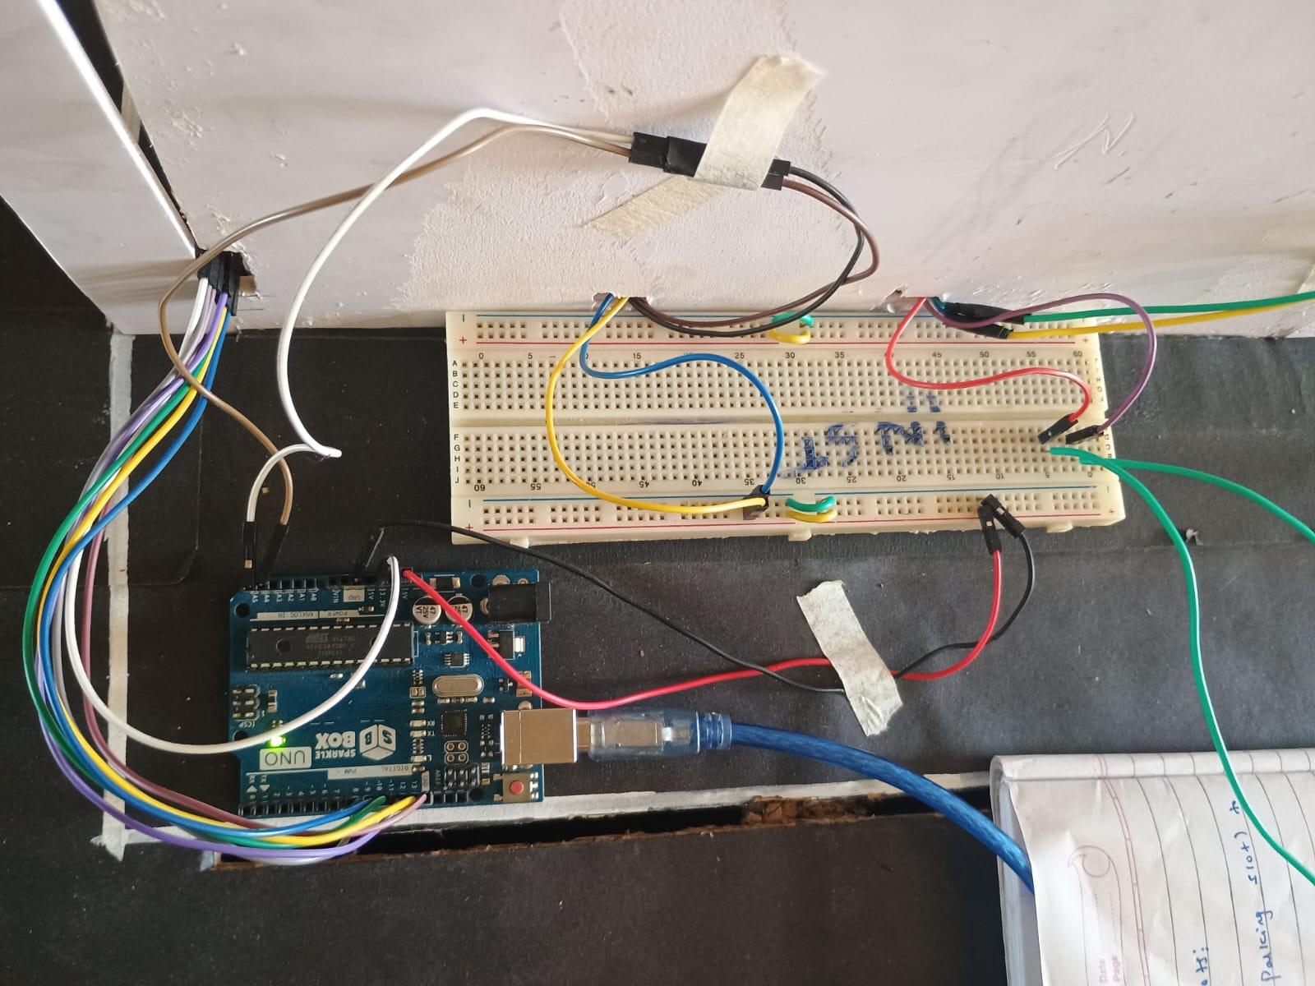

Figure 13 Entry Gate with Arduino UNO (I)

Working:

Integrating an Arduino board with an LCD screen into your parking system project for the entry gate can provide real-time feedback and enhance user interaction. Connect the Arduino board to the necessary peripherals such as the RFID reader and gate control mechanism. Wire the LCD screen to the Arduino according to its datasheet or pinout diagram. Typically, LCD screens use parallel or serial communication. Ensure proper power supply for all components.

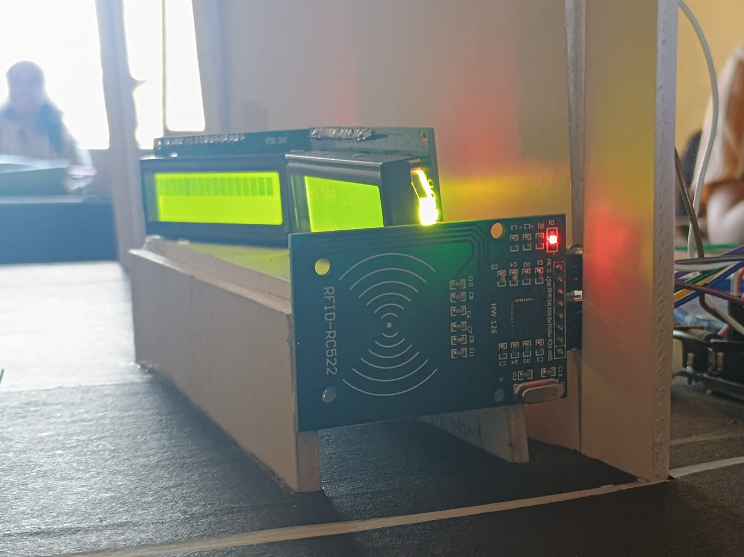

Figure 14 RFID TAG and LCD Working

Working:

Each vehicle authorized to access the parking area is equipped with an RFID tag. These tags contain unique identification information that the reader can recognize. Installed at the entry gate, the RFID reader constantly scans for nearby RFID tags. When a vehicle with an authorized RFID tag approaches the gate, the reader detects the tag's presence. Connected to the RFID reader, the access control system validates the RFID tag's information. It checks whether the tag belongs to a vehicle with permission to enter the parking area.

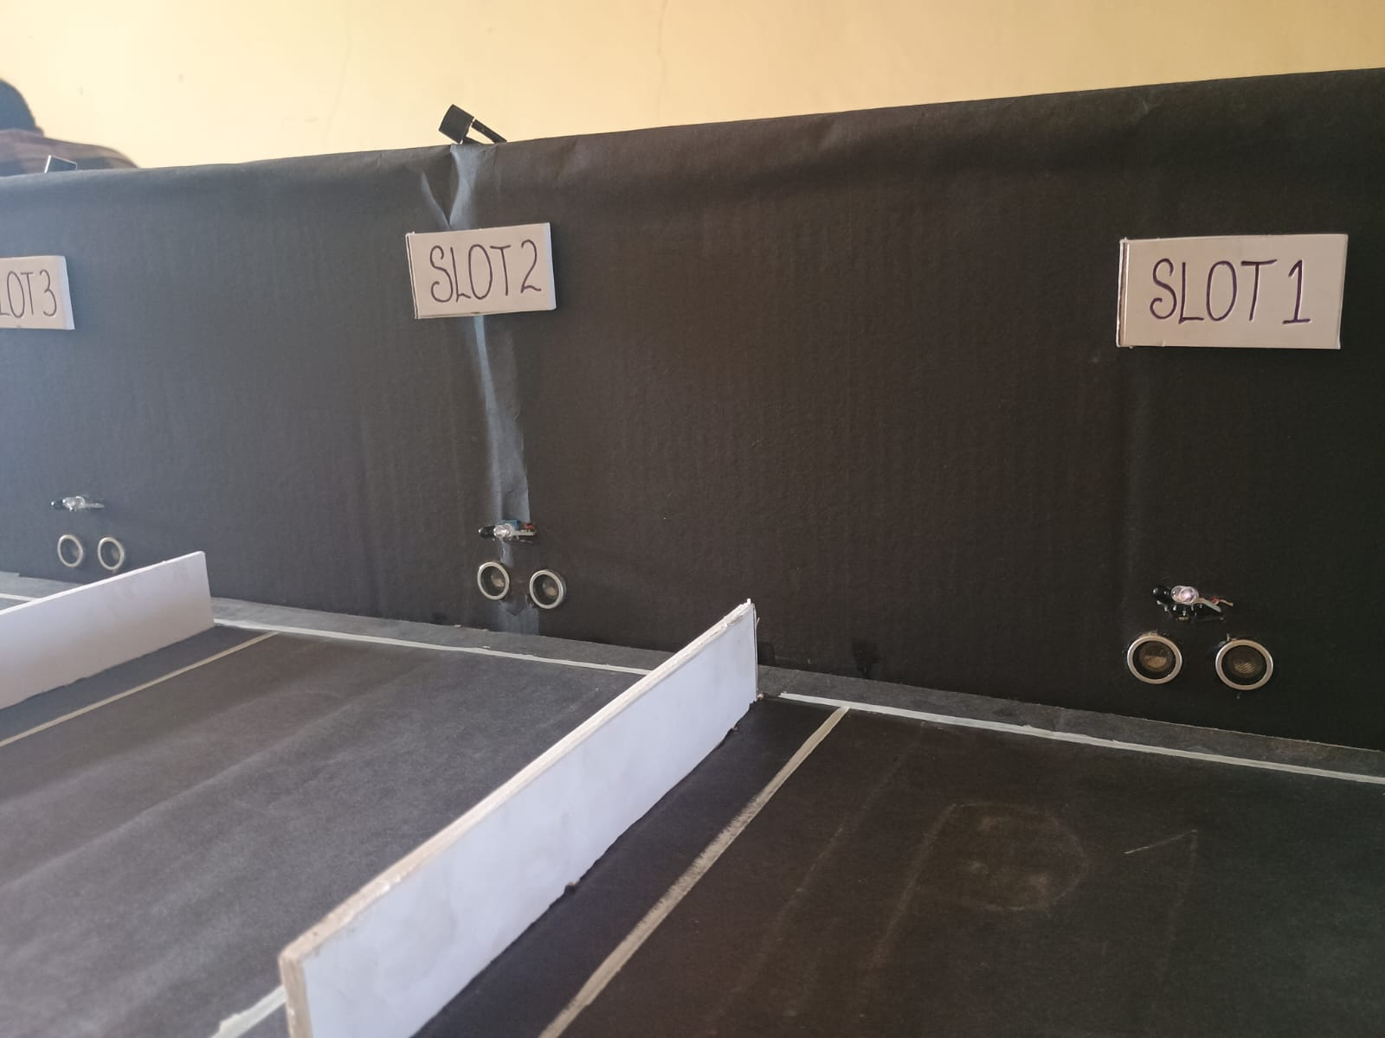

Figure 15 Parking Slots

Working:

In our parking system project, each parking slot is equipped with sensors for real-time monitoring and management of vehicle occupancy. Incorporating both proximity sensors and ultrasonic sensors in our parking system project ensures comprehensive protection for parking slots, enabling real-time monitoring and safeguarding against unauthorized access or potential collisions.

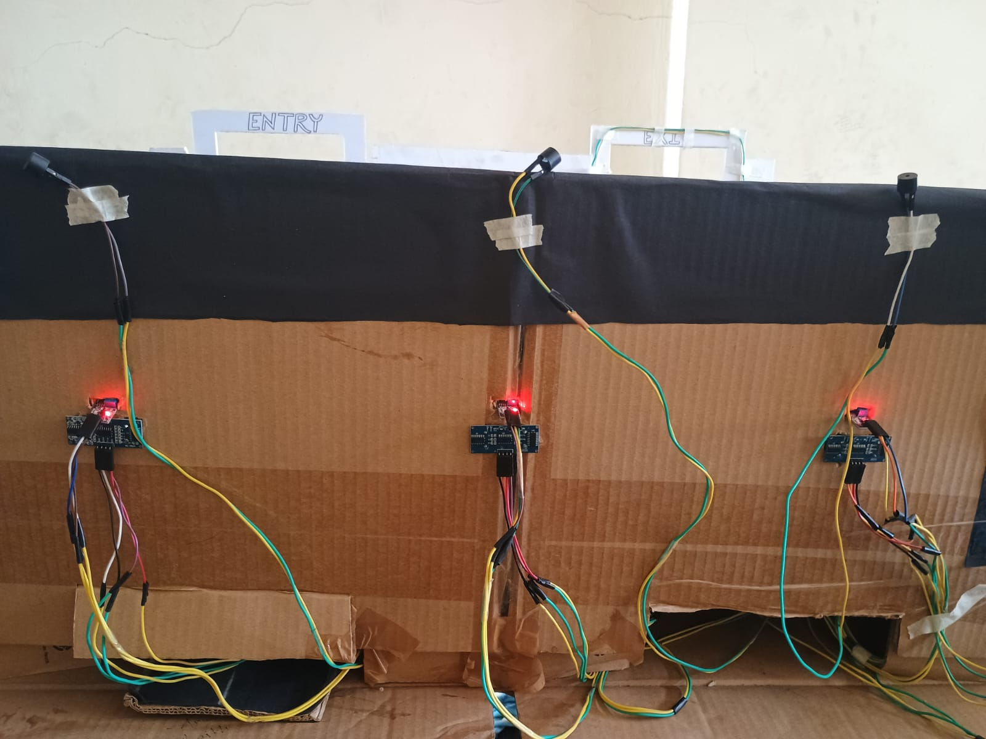

Figure 16 Connection of Parking Slots

Working:

The ultrasonic sensors continuously monitor the distance between the vehicle and any obstacles within the parking space. If the ultrasonic sensors detect an object too close to the vehicle, indicating a potential collision or difficulty in parking, the microcontroller triggers the buzzer to emit an audible alert. Simultaneously, the proximity sensors provide additional coverage by detecting the presence of objects in the vicinity of the vehicle, enhancing the system's ability to prevent accidents and ensure safe parking maneuvers.

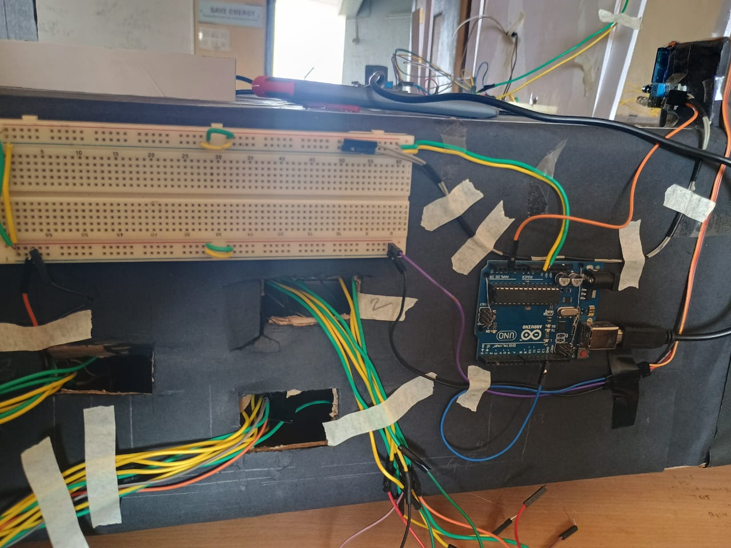

Figure 17 Exit Gate Arduino UNO (II)

Working:

The Arduino Uno connections implemented for integrating both a servo motor and a proximity sensor into our parking system, facilitating precise control of parking barriers and real-time detection of vehicle proximity for enhanced safety and efficiency.

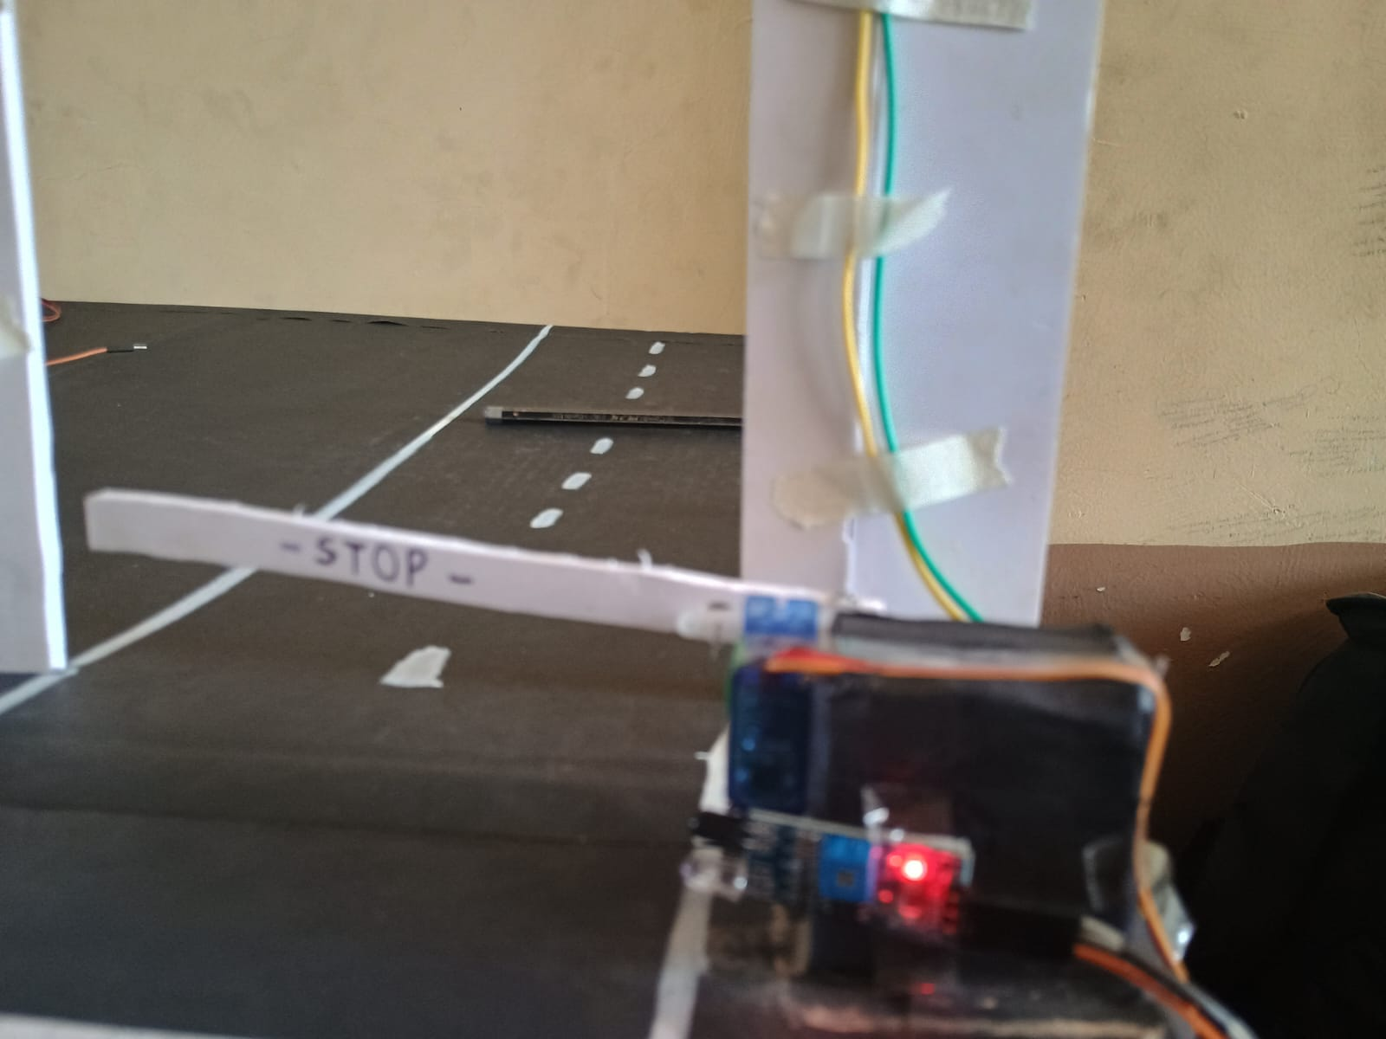

Figure 18 Exit Gate Working

Working:

The servo motor is programmed to open the gate automatically upon detection of a vehicle by the proximity sensor, ensuring seamless and convenient access for incoming vehicles.

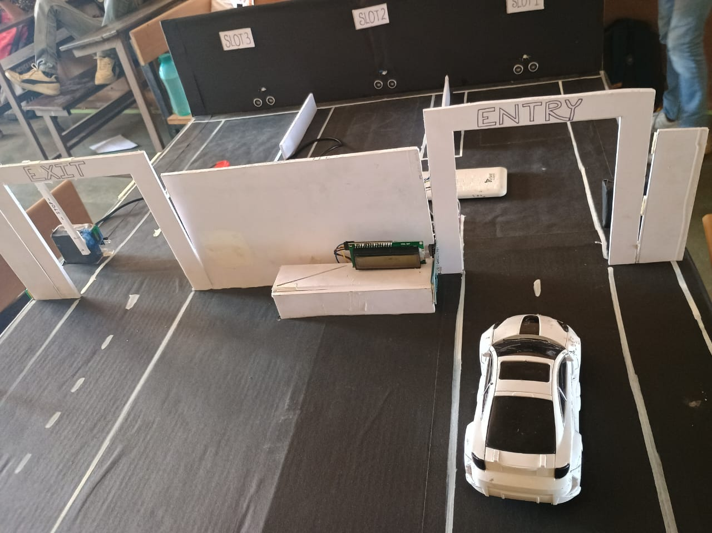

Figure 19 Project Model

## Previous work

Park-O-Matic System emerges as a beacon of efficiency and convenience. This system utilizes an arsenal of advanced technologies, including Arduino microcontrollers, IR sensors, ultrasonic sensors, servo motors, Buzzers and LCD displays, to transform the parking experience. By integrating these components, it not only optimizes the utilization of parking spaces but also enhances user accessibility and experience. In this system, IR sensors monitor individual parking spots for vehicle presence, while ultrasonic sensors gauge overall parking lot occupancy. The Arduino micro controller processes this data in real-time and controls a servo motor, which in turn manages physical barriers where necessary. Furthermore, a LCD display at the entrance communicates real-time parking availability to drivers. As a result, this innovative system revolutionizes urban mobility, simplifying the search for parking spaces, reducing traffic congestion, and making the urban experience more seamless and user-friendly. This introduction delves into the inner workings of the proposed smart parking system, illustrating its potential to redefine how we interact with urban parking and navigate our increasingly crowded cities.

# **Chapter 5**

## Advantage

* **Automated Parking System**

The servo motor-controlled barriers can automate the entry and exit process, eliminating the need for manual operation by parking attendants.

* **Increased Efficiency**

RFID tags can be attached to vehicles, allowing for quick and efficient identification during entry and exit. This speeds up the parking process, reducing wait times and congestion.

* **Improved Security**

RFID technology provides secure access control. Only vehicles with authorized RFID tags can enter and exit the parking facility, reducing the risk of unauthorized access and theft.

* **Space Optimization**

The system can keep track of available parking spaces in real-time using RFID data. This information can be displayed to drivers, guiding them to vacant spots and optimizing space utilization.

* **Reduced Labor Costs**

With automation provided by servo motors and RFID technology, there's less need for manual labor for managing the parking facility, leading to cost savings.

* **Data Collection and Analysis**

The system can collect data on parking usage, entry/exit times, and occupancy rates using RFID technology. This data can be analyzed to optimize parking management, identify usage patterns, and plan for future expansion or improvements.

## 5.2 Disadvantage

* **Complexity**

Integrating multiple technologies like Arduino, servo motors, and RFID can increase the complexity of the system design, installation, and maintenance. This complexity may lead to longer development times and require specialized expertise.

* **Reliability**

The reliability of the system heavily depends on the quality of components, wiring, and programming. Malfunctions or failures in any of these components could disrupt parking operations and require troubleshooting and repairs.

* **Limited Scalability**

While Arduino-based systems are flexible, they may have limitations in terms of scalability for large-scale parking facilities. Managing a high volume of RFID tags and coordinating multiple servo motors could become challenging as the system grows.

* **Power Dependency:**

Arduino-based systems require a stable power supply to operate. Power outages or fluctuations could disrupt the system, potentially causing issues with gate operation or data loss.

* **Maintenance Requirements**

The system may require regular maintenance to ensure proper functionality of components like servo motors and RFID readers. This includes cleaning, calibration, and replacement of worn-out parts, which adds to operational costs.

* **Security Vulnerabilities**

While RFID technology offers secure access control, it is not immune to security vulnerabilities such as RFID spoofing or interception. Ensuring robust encryption and authentication mechanisms is crucial to prevent unauthorized access.

* **Compatibility Issues**

Integrating different components and technologies from various vendors may lead to compatibility issues or interoperability challenges. Ensuring compatibility and seamless integration may require additional effort and resources.

**Chapter 6**

**6.1 Conclusion**

In conclusion, the deployment of a Park-O-Matic represents a transformative step forward in urban infrastructure management. Through the integration of advanced technologies such as IoT sensors, data analytics, and mobile applications, smart parking systems offer a comprehensive solution to the perennial challenge of parking in densely populated areas.

One of the primary benefits of a Park-O-Matic is the optimization of parking space utilization. By providing real-time information on parking availability, drivers can quickly locate vacant spots, reducing the time spent circling the streets in search of parking. This not only enhances convenience for motorists but also alleviates traffic congestion and reduces carbon emissions associated with idling vehicles.

Moreover, the implementation ofPark-O-Matic enables more efficient use of existing parking resources. By analyzing data on parking occupancy patterns and demand trends, city authorities can make informed decisions regarding parking policies, pricing strategies, and infrastructure investments. This data-driven approach fosters a more sustainable and equitable distribution of parking spaces, ensuring fair access for all residents and visitors.

Additionally, Park-O-Matic contribute to improved urban mobility and accessibility. By facilitating seamless navigation to available parking spots, these systems enhance the overall transportation experience, promoting the use of alternative modes of transportation such as public transit, cycling, and walking. This, in turn, helps to reduce reliance on private vehicles, mitigate traffic congestion, and enhance the overall quality of life in urban areas.

Furthermore, Park-O-Matic offer benefits beyond mere convenience and efficiency. They also provide valuable insights into urban mobility patterns, consumer behavior, and environmental impact. By analyzing parking data, city planners can gain a deeper understanding of transportation trends and develop more effective strategies for sustainable urban development.

In conclusion, the implementation of a Park-O-Matic represents a win-win solution for cities and citizens alike. By leveraging technology to optimize parking space utilization, improve mobility, and reduce environmental impact, smart parking systems play a pivotal role in creating smarter, more liveable cities for the future. As technology continues to evolve and urbanization intensifies, smart parking will remain a key component of sustainable urban development strategies worldwide.

## 6.2 Future Scope

1. **Lifts for Vertical Parking Solutions**:

Lifts or automated parking systems can revolutionize the utilization of space in urban environments where land is scarce. Multi-level parking structures with vertical lifts can accommodate more vehicles in a smaller footprint. These systems can be designed to retrieve and park vehicles autonomously, reducing the need for large driving lanes and maximizing parking capacity.

1. **Big LCD Displays for Enhanced Visibility**:

Large LCD displays strategically placed at key entry points to parking facilities or along busy streets can provide real-time information on available parking spaces, directions to vacant spots, and pricing details. These displays can also showcase dynamic advertisements, public announcements, or city-wide alerts, enhancing their utility beyond parking management.

1. **Mobile Application for Seamless User Interaction**:

A mobile application serves as the primary interface for users, offering a seamless experience from finding parking to completing payment. Through the app, drivers can search for nearby parking facilities, reserve spots in advance, and receive navigation instructions to their designated spaces. The app can also integrate features such as loyalty programs, parking history tracking, and customer support chatbots to further enhance user engagement.

1. **Integration with Smart City Infrastructure**:

A future-oriented smart parking system can be integrated into broader smart city initiatives. Data collected from parking sensors and user interactions can be shared with other urban systems, such as traffic management, public transportation, and air quality monitoring. This integration enables city planners to make data-driven decisions to optimize urban mobility, reduce congestion, and improve overall quality of life for residents.

1. **Predictive Analytics for Demand Forecasting**:

By analyzing historical parking data and external factors such as events, weather, and traffic patterns, smart parking systems can develop predictive analytics models to forecast future parking demand. This enables parking operators to proactively adjust pricing, allocate resources, and implement traffic management strategies to meet anticipated demand fluctuations effectively.

1. **Environmental Sustainability**:

A holistic approach to smart parking can also address environmental concerns. By promoting the use of shared mobility services, electric vehicle charging stations, and incentivizing eco-friendly transportation options, smart parking systems can contribute to reducing carbon emissions and fostering sustainable urban development.

# **References**

[1] Smart Parking System based on IOT, [Hardik Tanti](https://www.researchgate.net/scientific-contributions/Hardik-Tanti-2175787373?_tp=eyJjb250ZXh0Ijp7ImZpcnN0UGFnZSI6InB1YmxpY2F0aW9uIiwicGFnZSI6InB1YmxpY2F0aW9uIn19), [Pratik Kasodariya](https://www.researchgate.net/scientific-contributions/Pratik-Kasodariya-2175786001), [Shikha Patel](https://www.researchgate.net/scientific-contributions/Shikha-Patel-2175776694), [Dhaval H Rangrej](https://www.researchgate.net/scientific-contributions/Dhaval-H-Rangrej-2175767268?_tp=eyJjb250ZXh0Ijp7ImZpcnN0UGFnZSI6InB1YmxpY2F0aW9uIiwicGFnZSI6InB1YmxpY2F0aW9uIn19), May 2020, International Journal of Engineering Research and V9(05).

[2] Review Paper on Smart Parking System, Anusha, , Arshitha M S, Anushri, , Geetanjali Bishtannavar, International Journal of Engineering Research & Technology (IJERT) ISSN: 2278-0181 Published by, www.ijert.org RTESIT - 2019 Conference Proceedings

[3] A. Khanna and R. Anand, "IoT based smart parking system," 2016 International Conference on Internet of Things and Applications (IOTA), Pune, India, 2016, pp. 266-270, doi: 10.1109/IOTA.2016.7562735.

[4] A new “Smart Parking” System Infrastructure and Implementation, Yanfeng Geng, Christos G. Cassandras, Division of Systems Engineering, and Center for Information and Systems Engineering Boston Univeristy, Brookline, MA, 02446, USA

[5] A Survey of Intelligent Car Parking System.*J. appl. res. technol* [online]. 2013, vol.11, n.5, pp.714-726. ISSN 2448-6736.

[6] A cloud based Smart Parking System based on IoT technologies, IEEE, [Thanh Nam Pham](https://ieeexplore.ieee.org/author/37085687652); [Ming-Fong Tsai](https://ieeexplore.ieee.org/author/37085450825); [Duc Binh Nguyen](https://ieeexplore.ieee.org/author/37085689326); [Chyi-Ren Dow](https://ieeexplore.ieee.org/author/37296026900); [Der-Jiunn Deng](https://ieeexplore.ieee.org/author/37411144500)

[7] Smart Parking System (SPS) Architecture Using Ultrasonic Detector, Amin Kianpisheh, Norlia Mustaffa, Pakapan Limtrairut and Pantea Keikhosrokiani, International Journal of Software Engineering and Its Applications Vol. 6, No. 3, July, 2012

[8] Smart parking solutions for urban areas, IEEE, [Elena Polycarpou](https://ieeexplore.ieee.org/author/37073300800); [Lambros Lambrinos](https://ieeexplore.ieee.org/author/37298937300); [Eftychios Protopapadakis](https://ieeexplore.ieee.org/author/37070634700).

[9] Low cost smart parking system for smart cities, IEEE, D. Vakula; Yeshwanth Krishna Kolli.